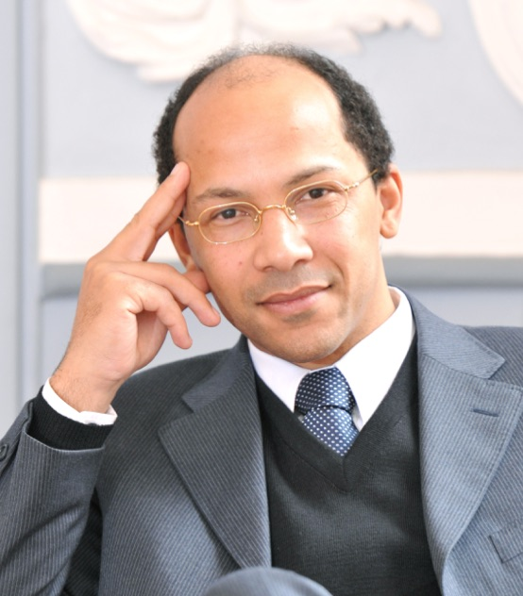
Nicolas Pompigne-Mognard - From Journalist to Successful Entrepreneur
Franco-Gabonese self-made entrepreneur Nicolas Pompigne-Mognard is the owner & former CEO of APO Group. Nicolas created APO Group on his own 11 years ago while he was journalist for online Gabonese media Gabonews and Deputy-President of the Panafrican Press Organization in France (APPA - Association de la Presse Panafricaine).
Having invested all his €10.000 of savings in 2007, Nicolas is the sole owner of a leading media relations consultancy firm working with more than 300 clients, ranging from governments to international institutions, prominent personalities and companies active in Africa and the Middle East.
Clients include companies like Facebook, Uber, Marriott, Hilton, GE, Orange, DHL, Philips, Coca-Cola, Standard Chartered Bank, Siemens, Canon, PwC, EY, McKinsey & Company, AccorHotels, flydubai, DP World, just to name a few. While APO Group’s Advisory division also serve clients like Aliko Dangote, the International Criminal Court and many more.
APO Group’s strategic partners include Bloomberg, Thomson Reuters, Nasdaq, Getty Images, CNBC Africa and Africanews a subsidiary Euronews.
APO Group is also the Main Official Sponsor of World Rugby’s African association, Rugby Africa.
During his 11 years as CEO at APO Group, Nicolas has been growing the company as well as serving and advising hundreds of multinational companies investing and doing business in Africa. Nicolas is now Chairman and focuses on delivering high-level counsel for the company’s clients and developing his investment fund dedicated to Africa.
Nicolas successively served as Deputy-Director of the French regional daily newspaper fr: Le Petit Journal, Director of FNSEA farmer's Union in Tarn-et-Garonne (France), parliamentary assistant at the French parliament (Assemblée (France), correspondent in Europe of Gabonese press agency, fr: Gabonews, and Special-Adviser to the President of the Panafrican Press Association in France (APPA), before he created APO Group in October 2007.
Pompigne-Mognard grew up in Valence d'Agen (France), and studied law at the Université de Lille.
Pompigne-Mognard is married with three children and lives in Lausanne, Switzerland.
Download the picture: https://bit.ly/2r0gYSW

